EXPERIMENT 7 B

DATA VISUALIZATION USING TABLEAU

Aim
To connect, analyze, visualize, and create interactive dashboards using Tableau with the patient dataset.

Algorithm 1 – Connecting Data Source
Step 1 Open Tableau.
Step 2 Select Connect → Text File.
Step 3 Browse your CSV dataset.
Step 4 Open the dataset.
Step 5 Verify the imported data.

Output

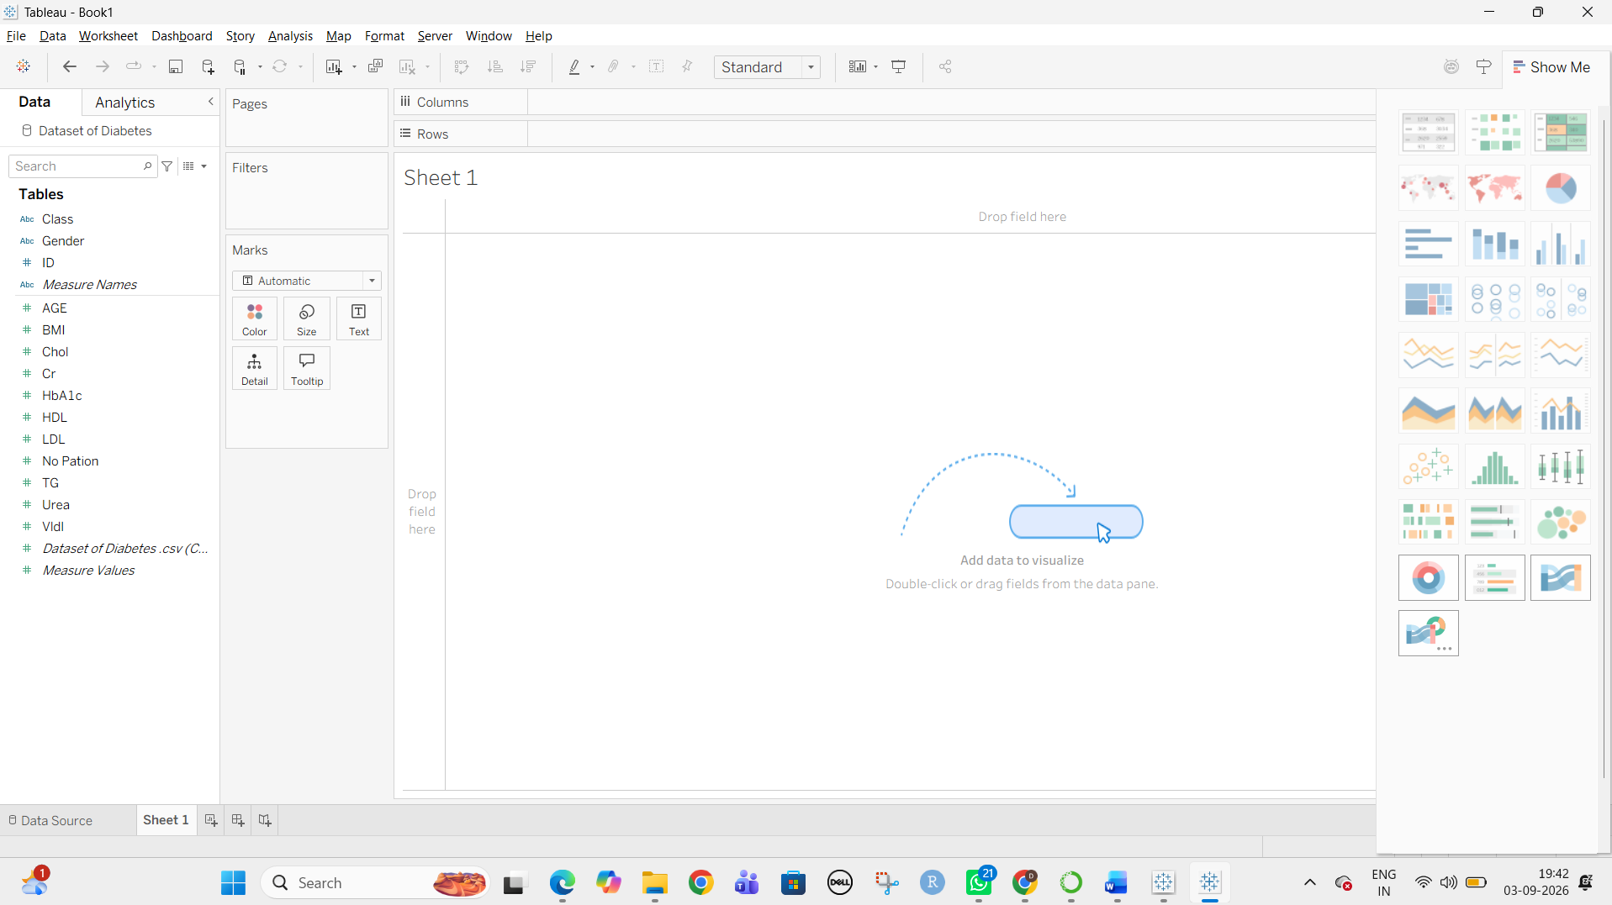

Algorithm 2 – Creating Worksheet
Step 1 Open Sheet 1.
Step 2 Drag Gender to Columns.
Step 3 Drag AGE to Rows.
Step 4 Select visualization.
Step 5 Analyze the result.

Output

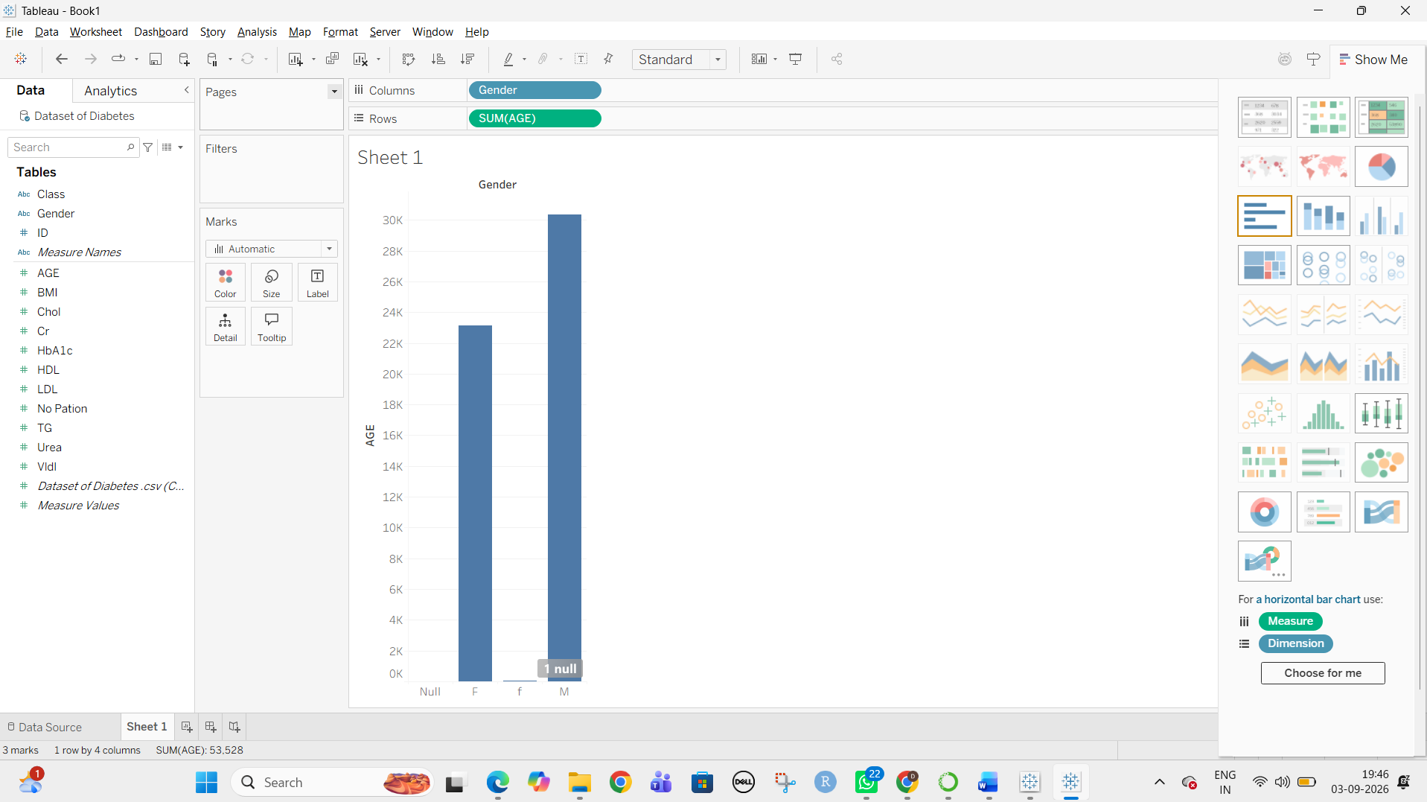Algorithm 3 – Bar Chart Creation
Step 1 Drag Gender → Columns.
Step 2 Drag ID → Rows.
Step 3 Change aggregation to Count.
Step 4 Select Bar Chart.
Step 5 Show labels.

Output

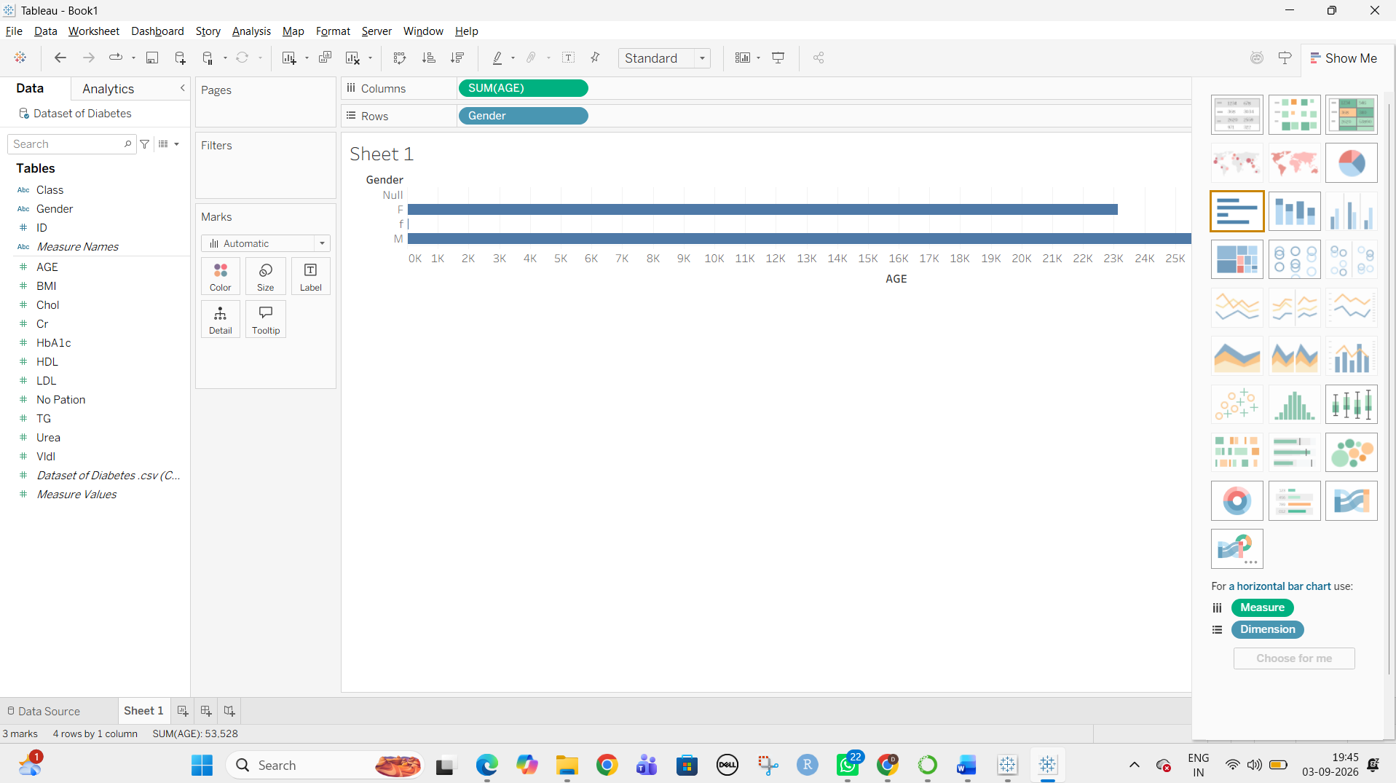

Algorithm 4 – Pie Chart Creation
Step 1 Drag CLASS to the view.
Step 2 Drag ID to Angle.
Step 3 Change ID to Count.
Step 4 Select Pie Chart from Show Me.
Step 5 Enable labels.

Output
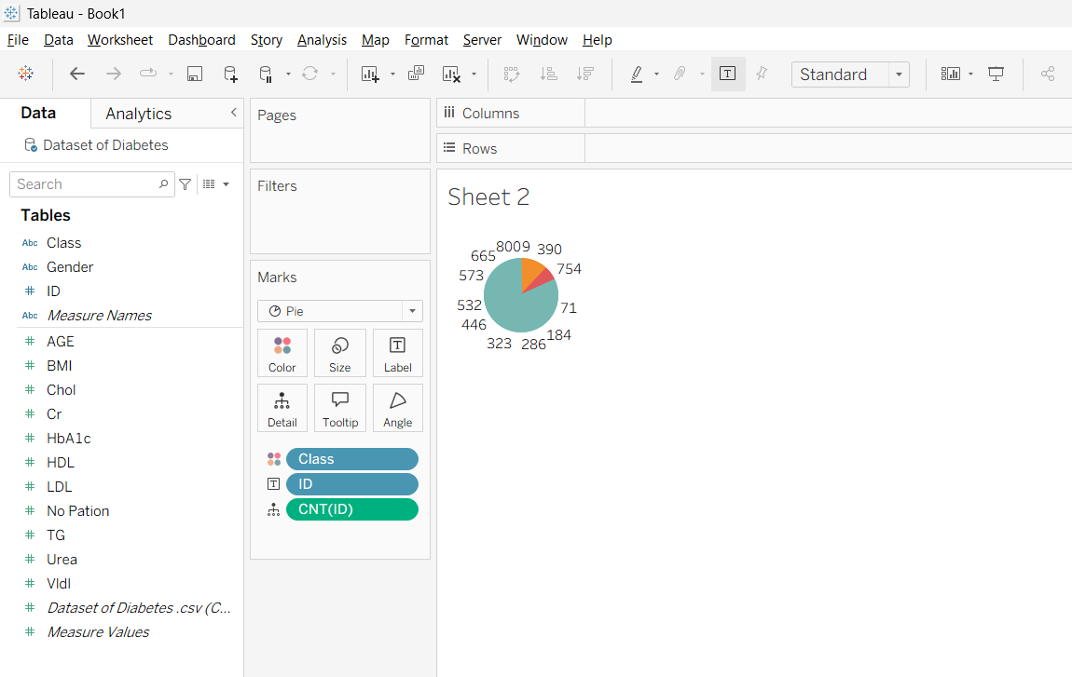

Algorithm 5 – Line Chart Creation
Step 1 Drag ID → Columns.
Step 2 Drag AGE → Rows.
Step 3 Select Line Chart.
Step 4 Apply formatting.

Output
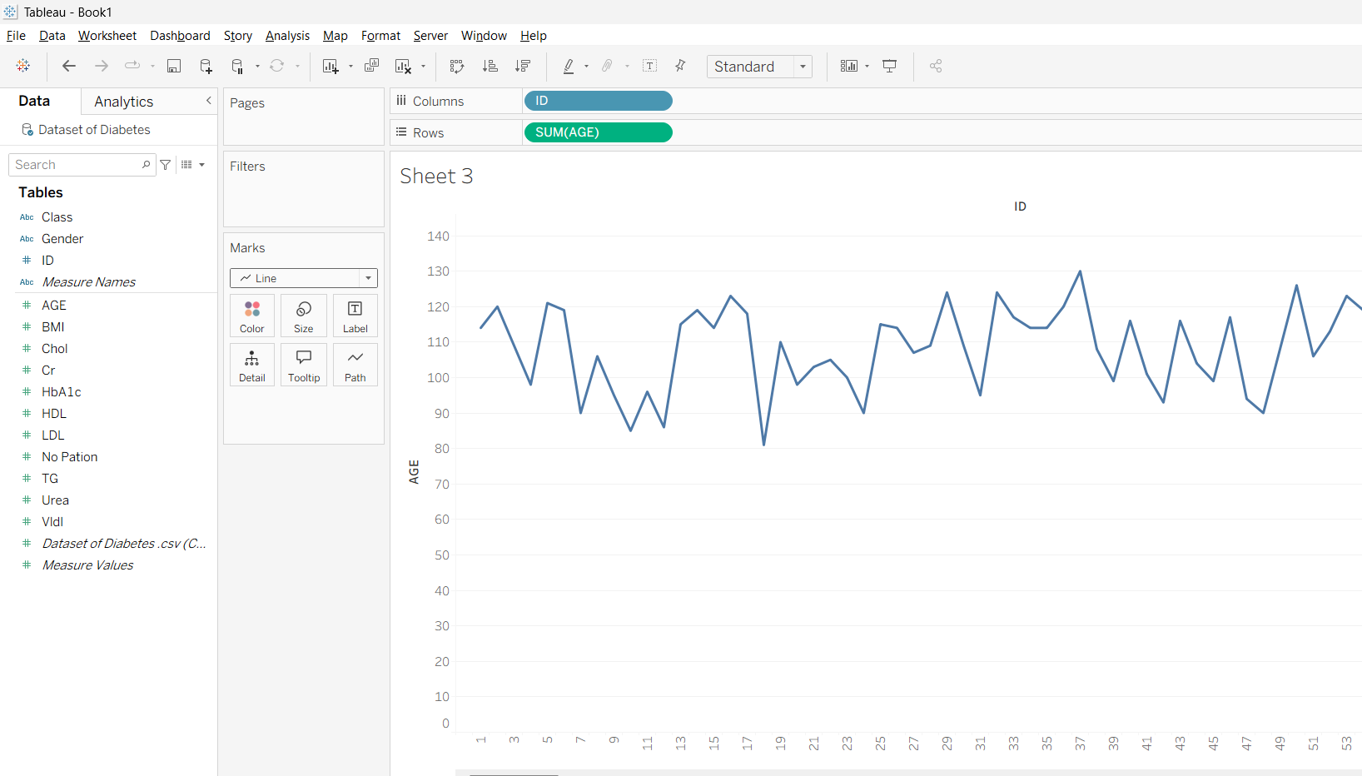

Algorithm 6 – Creating Calculated Field

Step 1
Go to:
Analysis → Create Calculated Field

Step 2
Enter name:
BMI Category

Step 3
Enter formula:
IF [BMI] < 18.5 THEN "Underweight"
ELSEIF [BMI] < 25 THEN "Normal"
ELSEIF [BMI] < 30 THEN "Overweight"
ELSE "Obese"
END

Step 4
Click OK.

Output
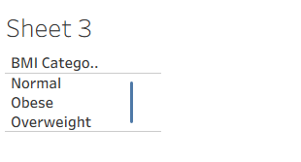

Algorithm 7 – Applying Filters
Step 1 Drag Gender to Filters.
Step 2 Select the required gender.
Step 3 Click OK.
Step 4 Observe the updated charts.

Result
Thus, the patient dataset was successfully connected, analyzed, visualized, filtered, and presented using Tableau dashboards and interactive visualizations.

